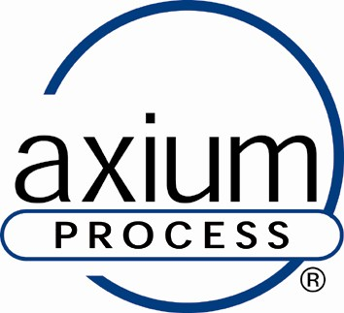

Vacancy – Welder/Fabricator

Axium Process specialises in the fabrication and supply of stainless-steel pipework and membrane separation systems, for the pharmaceutical, food and beverage, dairy, chemical, cosmetic and toiletries industries. Currently, employing around 64 personnel and manufacturing from a 30,000 ft2 facility based on the Hendy Industrial Estate, Swansea. This is an exciting opportunity to be part of a growing organisation with the objective to be number one in its market.

Key skills needed:

- Experienced stainless-steel fabricator/welder – ideally experienced with thin wall 1.6mm - 5mm stainless tube and plate.
- Must have extensive TIG stainless steel welding experience.
- Must be able to interpret engineering drawings.
- Experience of hygienic pipework would be an advantage.
- Experience in sheet metal work would be an advantage.
- Sitework experience and the willingness to work on-site would be an advantage.

Qualifications
Must be time-served.

Wage: Wage dependent upon relevant experience. (£16 per hr)
Location: Hendy Industrial Estate, Hendy.
Duration: Permanent position.
Hours: 37.75 hrs/week (Monday-Thursday 08.00 – 16.30 & Friday 08.00 – 14:15).

Application Forms are available from our personnel department.
Email – karen.thomas@axiumprocess.com

